

City of Greencastle

Improvement Location Permit Application Package

12 Processes and Permits | 12.6 Improvement Location Permit
Improvement Location Permit  See Also: Article 7, Site Development Plans  See Also Chapter 12.8, Sign Permits | The following procedure applies to Improvement Location Permit applications:  - General Requirements: No structure or major infrastructure shall be erected, moved, or added to, without an Improvement Location Permit issued by the City Planner. No Improvement Location Permit shall be issued unless the project is in conformity with the provisions of this Ordinance, the Subdivision Control Ordinance and other applicable regulations of the City of Greencastle. When applicable, consistent with Article 7 of this Ordinance, Site Development Plan review and approval shall be completed prior to the receipt of an Improvement Location Permit.  - Permit Required: The City of Greencastle requires that an Improvement Location Permit be obtained for the following:  - any structure, for any use that exceeds 120 square feet in area and/or has a permanent foundation (including structures other than buildings such as towers, antennas, and satellite dishes),  - any temporary use of land or temporary structure,  - signs (as specified by Chapter 12.8 of this Article) ,  - swimming pools (in ground or above ground),  - additions to all structures,  - demolition,  - surface and sub-surface drainage work and/or grading (including land alteration) excluding agricultural uses,  - public road cuts,  - driveways,  - storm sewer hook-ups,  - removal or trimming of required trees and plants within buffer yards and landscaping areas otherwise required by this Ordinance,  - adding or subtracting dwelling units or leased space in multifamily or commercial structures,  - placement or replacement of manufactured or mobile homes,  - parking lot construction or alteration,  - ponds or lakes,  - mineral extraction,  - the change of use of any property or structure,  - telecommunication towers, buildings, and antenna, and  - any exterior construction that adds to or alters the height of the existing structure.  - Exemptions: No ILP shall be required for the following types of improvements. However, any such improvement shall comply with any applicable requirements of this Ordinance, the Subdivision Control Ordinance, and any other applicable adopted standards of the City of Greencastle.  - fences, walls, and hedges placed outside of the public right-of-way,  - residential driveways and sidewalks, which are less than 500 square feet in area, located entirely on private property and not required to be provided by this Ordinance, the Subdivision Control Ordinance, or any other applicable adopted standards of the City of Greencastle.

ZONING ORDINANCE 12-12
2002 - RATIO ARCHITECTS INC.

12.6 Improvement Location Permit (cont.) | Processes 12  and Permits
3. cosmetic (non-structural) changes to any structure including the replacement of windows in existing openings, re-roofing, the installation of siding material, and repainting.  - Application Requirements: All applications for improvement location permits shall be accompanied by:  - Site Location Map: a site location map showing the subject property and the general features of the property within 500 feet of the subject property;  - Site Plan (if applicable): a detailed site plan, drawn to scale with the dimensions indicated showing the following:  - the entire property and the features of the property including all rights-of-way, easements, property lines, required buffer yards, and setbacks;  - all existing and proposed structures or other site improvements with the dimensions of such improvements;  - the distances from all existing and proposed improvements to the property lines;  - the location of any existing or proposed septic field;  - the location of any existing or proposed driveway and/or parking areas;  - elevations of all existing and proposed structures or alterations;  - natural, physical or hazardous conditions existing on the lot;  - the location of any required landscaping, labeled according to size and species,  - the location, type, and dimensions of any storm water structures, conduits, or detention/retention ponds, and  - finished floor elevations.  - Waste Disposal Verification: Either a septic permit from the Putnam County Health Department or a sewer access (tap-on) permit from the appropriate public sewer provider (if applicable);  - Driveway Approval (if applicable): A driveway permit from the City Engineer (if applicable);  - Use Description: A detailed description of the existing or proposed uses of the property and any structures;  - Dwelling Units/Tenant Spaces (if applicable): An indication of the number of dwelling units, or tenant spaces the building is designed to accommodate;  - Building Permit (if applicable): a Building Permit consistent with the requirements of the Greencastle Building Code and the procedures of the Building Official; and  - Flood Hazard Area Information: (if applicable) any other information necessary to meet the requirements of Section 9.5 (C) of this Ordinance.  - Copies: A copy of all submitted plans and application materials shall be retained by the City Planner for the permanent records of the City of Greencastle Plan Commission. | Improvement Location  Permit  See Also: Section 9.5 (C)

2002 - RATIO ARCHITECTS INC.

12-13

CITY OF GREENCASTLE

12 Processes and Permits | 12.6 Improvement Location Permit (cont.)
Improvement Location Permit | - Expiration of Permits: Improvement location permits shall expire consistent with the following provisions:  - Initiation of Work: If the work described in any improvement location permit has not begun within 3 months from the date of issuance, said permit shall expire; no written notice shall be given to the persons affected.  - Completion of Work: If the work described in any improvement location permit has not been completed within 1 year of the date of its issuance, the permit shall expire; no written notice shall be given to the persons affected.  - The City Planner may grant 2 extensions for up to 1 year each for work completion. Requests for extensions must be received within 1 month of the expiration.  - No extension shall be granted unless all appropriate extension fees, as defined by the adopted fee schedule, are paid to the City Planner and the project continues to conform with all applicable require- ments of the City of Greencastle.  - Construction According to Permits and Permit Application: Improvement location permits issued on the basis of plans and applications only authorize the use, arrangement, and construction set forth in such approved plans and applications. Any other use, arrangement, or construction not authorized shall be deemed a violation of this Ordinance and subject to the provisions of Article 13, Enforcement and Penalties of this Ordinance.

ZONING ORDINANCE 12-14
2002 - RATIO ARCHITECTS INC.

12.7 Certificate of Occupancy | Processes 12  and Permits
The following procedure applies to Certificates of Occupancy:  - Certificate Requirements: It shall be unlawful and in violation of the provisions of this Ordinance for any builder or property owner to allow any new or significantly remodeled structure to become occupied or utilized prior to:  - legally obtaining an Improvement Location Permit,  - passing all required inspections, including the final inspection; and  - receiving a Certificate of Occupancy from the City Planner.  - Inspection: Upon the completion of the work approved through an improvement location permit, the permit holder shall contact the City Planner and schedule an inspection to verify the installation of improvements consistent with the requirements of this Ordinance. The City Engineer, Building Official, any other municipal official, and any other person requested by the City Planner may also take part in the inspection.  - Certificate Issuance: The City Planner shall issue the Certificate of Occupancy if the improvements comply with all applicable requirements of the City of Greencastle, including this Ordinance, the Subdivision Control Ordinance, and all applicable Building Codes as verified by the Building Official. | Certificate of Occupancy

2002 - RATIO ARCHITECTS INC.

12-15

CITY OF GREENCASTLE

Current Code Sets in Use
The following is a list of the current codes sets adopted by the State of Indiana and in use by the City of Greencastle. Also included are links to the State of Indiana website where you can check for current code sets, download the amendments and file building plans for CDR. This will provide you with the Indiana Codes when added to the corresponding code book.
- 2012 International Building Code (1st printing adopted by Indiana)
- 2012 International Fire Code (1st printing adopted by Indiana)
- 2012 International Mechanical Code (1st printing adopted by Indiana)
- 2006 International Plumbing Code 2nd printing, Indiana Edition
- 2012 International Fuel Gas Code (2nd printing adopted by Indiana)
- 2003 International Residential Code (5th printing, part of the Indiana Residential Code)
- 2005 Indiana Residential Code Combo
- 2005 Indiana Amendments to the 2003 IRC
- 2008 National Electrical Code®

State of Indiana Codes, Standards and other Rules: http://www.in.gov/dhs/2490.htm

State of Indiana Construction Design Releases: http://www.in.gov/dhs/2650.htm

Fire Prevention & Building Safety Commission / Code Services: http://www.in.gov/dhs/2375.htm

Indiana General Administrative Rules (Amendments): http://www.in.gov/legislative/iac/T06750/A00120.PDF

Thank you,

Pat Thibodeau Building Commissioner City of Greencastle Building Division
Office (765) 653-8522 / Cell (765) 301-0456

§ 7-22 BUILDING AND CONSTRUCTION REGULATIONS § 7-22 (

See. 7-22 Building Permit Fees and Single Inspection Fees.
Permits required by Section 7-20 shall be issued upon prior payment of inspection fees according
to the following schedule:

APPENDIX A

Type of Construction | Required Inspections | Single Inspection Fee | Permit Fee
One or Two Family Dwelling | 4 | $30.00 | $120.00 per unit**
Multi-Family Apartments, Hotels, Motels | 3 | $30.00 per unit | $90.00 per unit*
Business, Commercial, Public | 6 | $30.00 | $180.00*
Educational, Institutional, Church | 6 | $30.00 | $180.00*
Self-Storage, Shed, Industrial, Warehouse, Bulk Storage | 4 | $30.00 | $120.00*
Mobile Homes, Temporary  Structures | 1 | $30.00 | $30.00
Accessory Buildings (Residential | 1 | $30.00 | $30.00*
Additions/Alterations  (Residential} | 3 | $30.00 | $90.00
Bectrical | 1 | $30.00 | $30.00
Roof | 1 | $30.00 | $30.00
Sign | 2 | $30.00 | $60.00***
Demolition | 1 | $25.00 | $25.00
Zoning | 1 | $25.00 | $25.00
Certificate of Occupancy | 1 | $10.00 | $10.00

- Plus $.05 per square foot.
** Plus $.OS per square foot over 1,000 square feet.
***Plus $.050 per square foot of sign face.

(Ord. No. 1997-3, Appendix A, 3-11-97)

i
\,

322

§ 7-35 BUILDING AND CONSTRUCTION REGULATIONS §7-36

Sec.7-35 Enforcement and Appendix C.

Violations designated in "Appendix C" which is set forth herein, may be paid to the Violations Clerk upon acknowledgement of the violations and cessation of the violation. (Ord. No. 1997-3, § 845-107, 3-11-97)

b. Appendix C

APPENDIX C
VIOLATIONS FINE SCHEDULE
 | 1ST 0FFENSE | 2ND 0FFENSE | 3RD 0FFENSE
1. Construction Without a Permit | $25.00 | $50.00 | Per 7-36
2. Continuing Work Without Proper Inspection and approval of same | $25.00 | $50.00 | Per 7-36
3. Occupying Dwelling (or portion under construction) without certificate of occupancy | $25.00 | $50.00 | Per 7-36
4·, Use of Swimming Pool without Final Inspection and approval of same | $50.00 | Per 7-36
5. Alteration of construction drawings, methods, and/or materials without notification to Building Commissioner | $25.00 | $50.00 | Per 7-36
6. Continuing Work after a Stop Order has been issued | $50.00 | Per 7-36
7. Failure to allow entry per 845-75 of this Ordinance | $50.00 | Per 7-36
8. Work not ready for scheduled inspections | $20.00 | $20.00 | $20.00

(
(Ord. No. 1997-3, Appendix C, 3-11-97, Ord. No. 2006-1)

Sec.7-36 Penalties.

In the event any person, firm, corporation or entity shall violate any of the provisions of this code, or shall do any act prohibited herein, or shall fail to perform any duty lawfully enjoined, within the time prescribed by the Building Commissioner, or shall fail, neglect or refuse to obey any lawful
. order given by the Building Commissioner in connection with the provisions of this code for each such violation, failure or refusal, such person, firm, corporation, or entity shall be fined in any sum not less than twenty dollars ($20.00), nor more than two-thousand, five-hundred dollars ($2,500.00). Each day of the violation shall be considered a separate violation. Such person, firm, corporation, or entity shall further be required to pay any and all costs incurred by the City of Greencastle as a result of violations by said person, firm, corporation or entity of the provisions of this Code and ordinance as amended from time to time, including attorney fees and the like. (Ord. No. 1997-3,
§ 845-110, 3-11-97, Ord. No. 2006-1)

327

REQUIRED INSPECTIONS
(But not limited to)

THE CITY OF GREENCASTLE REQUIRES THE FOLLOWING INSPECTIONS BE COMPLETED ON EACH CONSTRUCTION PROJECT:

- PRELIMINARY INSPECTION (PRE-PERMIT) FOR ADDITIONS/REMODELS
- FOOTINGS – PRE-POUR
- FOUNDATION WALLS
- WATER PROOFING
- FOUNDATION DRAINAGE
- CONCRETE SLAB – PRE-POUR
- FRAMING
- PLUMBING
- ELECTRIC
- HVAC
- OTHER/SPECIAL INSPECTIONS AS REQUIRED
- FINAL – CERTIFICATE OF OCCUPANCY

THE RESPONSIBILITY OF CALLING FOR APPOINTMENTS SHALL BE THAT OF THE OWNER OR CONTRACTOR. THE ABOVE REQUIRED INSPECTIONS THAT CANNOT BE VIEWED BY THE INSPECTOR SHALL BE UNCOVERED OR EXCAVATED.
ALL REQUIRED INSPECTIONS SHALL BE COMPLETED BEFORE A CERTIFICATE OF OCCUPANCY WILL BE ISSUED.

I HAVE READ AND UNDERSTAND THE REQUIREMENTS OF THE INSPECTION PROCESS.

OWNER / CONTRACTOR DATE

PAT THIBODEAU, BUILDING INSPECTOR GREENCASTLE FIRE DEPT., BUILDING DIVISION 1 N. LOCUST STREET
GREENCASTLE, IN 46135
OFFICE 765-653-8522

24 HOUR NOTICE FOR INSPECTIONS

48 HOUR NOTICE FOR FINAL INSPECTIONS

UTILITY TAP FEES SHALL BE PAID BEFORE THE IMPROVEMENT LOCATION PERMIT CAN BE ISSUED.

NO SITE WORK SHALL BEGIN OR FOUNDATION PERMITS ISSUED UNTIL ALL RULE 5 AND MS4 REQUIREMENTS ARE MET.

APPROVAL WILL BE ON AUTHORITY OF THE PLANNING AND ENGINEERING DEPARTMENTS.

C ITY O F GR EENCASTLE
..- ·A NITA RY S EW ER
LATERA L·. .:.:. CO NSTR UCTIO N DETA I L

lliIIl& SAW CUT
EXISTING PAVEMENT
5" DEEP (MIN.) EACH SIDE

FlNAL SAW CUT
EXISTING PAVEMENT
2·DEEP (MIN.) EACH SIDE
E

,
FINA L CUTB A CK TA B
8 TR ENCH WID TH
g· | 3·-1• To s·-o·
12" | 5'-1" OR GREATER

MINIMUM CUIBACK
SEE TABLE
1.5" 9.5 mm HMA SURFACE

5" (MIN.) 25 mm BASE

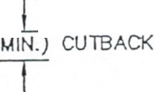
TWO OR MORE (4• MAX.)
COMPACTED LIFfS f......4-,..+-,....+->--- ._..,..

TACK COAT ON
EDGES ANO SUBBASE SEE NOTES

INDOT TYP£ 1 ffi TYP£ 2
FLO\IABLE BACKFILL

12'

6 ' HIN -+---<
PIPE BEDDING
I('lDOT MB CRUSHED UKESTONE

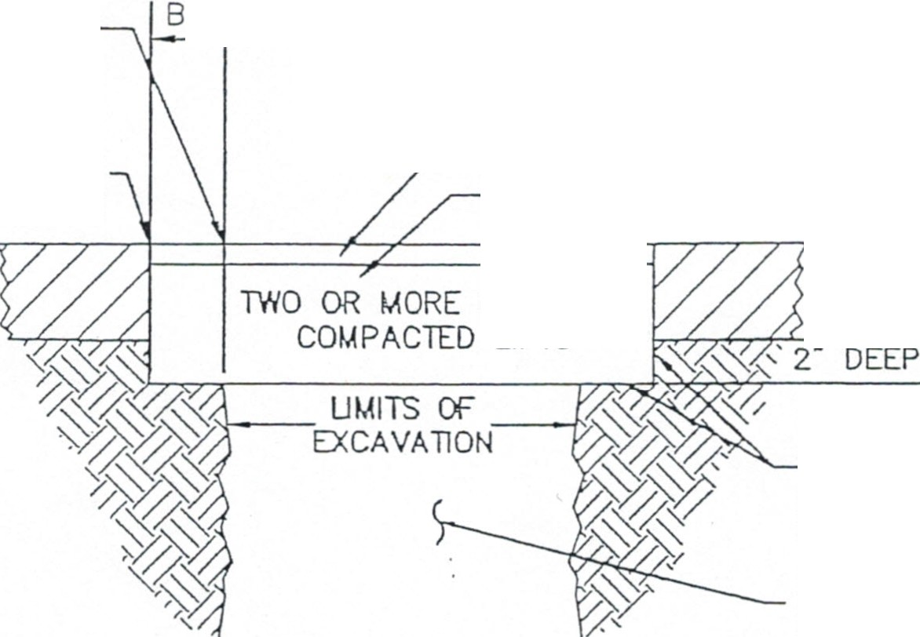
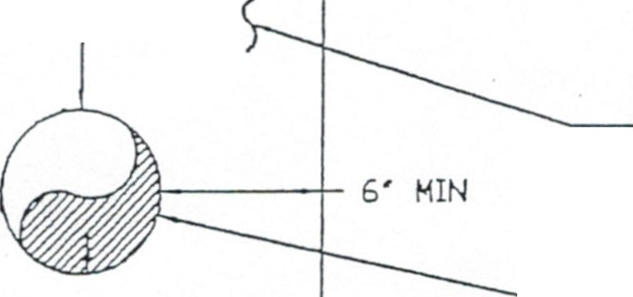
-..... HlNIHUH 6' SEVER LATERAL SDR 35 PVC ·
3'

(FLOWABLE MORTAR SHALL NOT BE USED WHEN TEMPER ATURES ARE BELOW 38. F)

A SPH A LT PA VEMEN T R EP AIR
<NOT TD SCALD

12 Processes and Permits | 12.8 Sign Permits
Sign Permits | The following procedure applies to Improvement Location Permits for Signs (Sign Permits):  - Sign Permit Review for Permanent Signs: The following procedure applies to Permanent Sign Permit Review.  - Application: Application for a permit shall be filed with the City Planner and shall be accompanied by any information the City Planner deter- mines is necessary to assure compliance with this Ordinance, including but not limited to:  - Clear and legible drawings with descriptions showing the location of the sign which is the subject of the permit. All signs on the same parcel or owned by the same business must be noted.  - A dimensioned drawing showing the size of the sign face area and the height of the sign.  - Effect of Sign Permit Issuance: A sign permit issued under the provi- sions of this section shall not be deemed to constitute permission or authorization to maintain an unlawful sign nor shall it be deemed as a defense in an action to remove an unlawful sign.  - Expiration: A sign permit shall become null and void if work has not been started within 30 days of the date the permit is issued or com- pleted within 6 months of the date the permit is issued.  - Sign Permit Review for Temporary Signs: The following procedure applies to Sign Permit Review for Temporary Signs.  - Application: Application for a permit shall be filed with the City Planner and shall be accompanied by any information the City Planner deter- mines is necessary to assure compliance with this Ordinance, including but not limited to:  - the type of temporary sign to be used.  - the period of time the temporary sign is to be used.  - the location at which the temporary sign is to be used, and the location on the property where the sign is to be placed.  - Effect of Sign Permit Issuance: A sign permit issued under the provi- sions of this section shall not be deemed to constitute permission or authorization to maintain an unlawful sign nor shall it be deemed as a defense in an action to remove an unlawful sign.  - Nullification: A temporary sign permit shall become null and void if the sign has not been placed within 30 days of the date the permit is issued.

ZONING ORDINANCE 12-16
2002 - RATIO ARCHITECTS INc.

